If you are using vSphere Replication 8.1.x, you can upgrade to version 8.2 by using a downloadable ISO image.

**Prerequisites**

* Download the VMware-vSphere_Replication-8.2.x.x-build_number.iso image from the vSphere Downloads page. Copy the ISO image file to a datastore that is accessible from the vCenter Server instance that you use with vSphere Replication.

**Procedure**

1. In the vSphere Client, right-click the vSphere Replication appliance virtual machine and select **Open Console**.
2. Log in as the root user, and run the following command.

if [ -d '/var/run' ] && [ ! -L '/var/run' ] ; then mv -f /var/run/* /run/; rm -rf /var/run; ln -sf /run /var/; fi

1. Right-click the vSphere Replication virtual machine and select **Edit Settings**.
2. On the **Virtual Hardware** tab, select **CD/DVD Drive** > **Datastore ISO File**.
3. Navigate to the ISO image in the datastore.
4. For **File Type**, select **ISO Image** and click **OK**.
5. Select the option to connect at power-on and follow the prompts to add the CD/DVD drive to the vSphere Replication virtual machine.
6. Power on the vSphere Replication virtual machine.
7. In a Web browser, log in to the virtual appliance management interface (VAMI).

The URL for the VAMI is https:// *vr_appliance_address*:5480.

1. Click the **Update** tab.
2. Click **Settings**, select **Use CDROM Updates**, and click **Save Settings**.
3. Click **Status** and click **Check Updates**.

The appliance version appears in the list of available updates.

1. Click **Install Updates** and click **OK**.

After the updates install, you see the message System reboot is required to complete the update. If you log out while the upgrade is running, log in to the VAMI again and click **Update** > **Status**. Wait to see the System reboot is required to complete the update message before rebooting the appliance to avoid interruption of the upgrade procedure.

1. Click the **System** tab and click **Reboot**.

After completed upgrades target site and remote site, open site Recovery in target site and remote site from both vcenters. Here you will see un-configured warning.

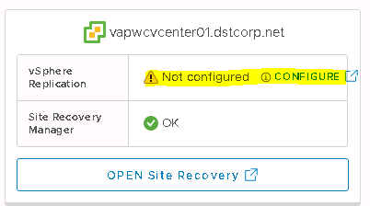

Click on Configure Tab—it takes you again vSphere Replication Appliance VAMI page

Enter root credentials

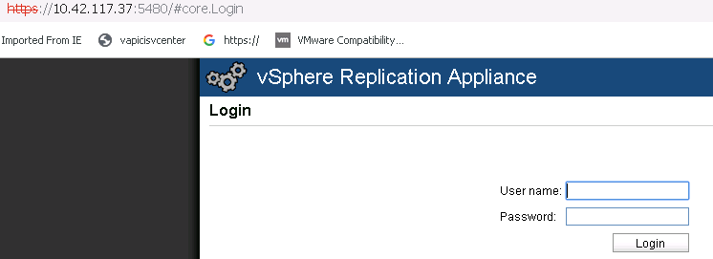

Select VR tab-🡪Configuration

Provide SSO Administratot Password and click save and Restart Service

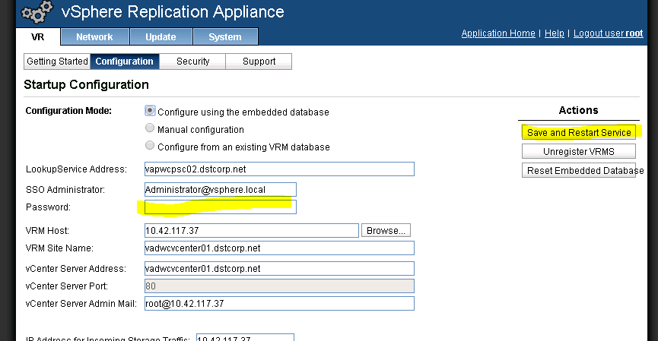

Once it save and restart services successfully, your site recovery should come to Okay state.

And existing configured VMs replication resume the replication.

